Experiment - 8
Operating Systems Lab
Syeda Reeha Quasar
14114802719
6C7
AIM
Write a program to implement Banker’s algorithm for deadlock avoidance.

EXPERIMENT – 8

Aim:
Write a program to implement Banker’s algorithm for deadlock avoidance.

Theory:
It is a banker algorithm used to avoid deadlock and allocate resources safely to each process in the computer system. The 'S-State' examines all possible tests or activities before deciding whether the allocation should be allowed to each process. It also helps the operating system to successfully share the resources between all the processes. The banker's algorithm is named because it checks whether a person should be sanctioned a loan amount or not to help the bank system safely simulate the allocation of resources.
Example:
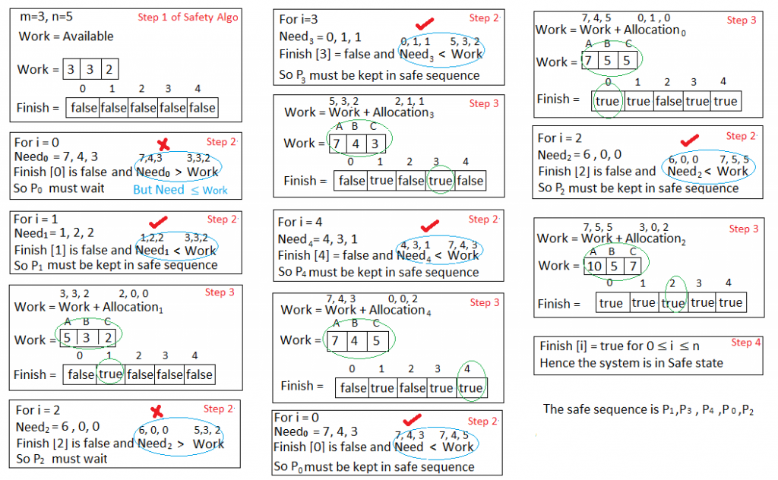

Source Code:

alloc=( 0 1 0 2 0 0 3 0 2 2 1 1 0 0 2 )
max=( 7 5 3 3 2 2 9 0 2 2 2 2 4 3 3 )
avail=(3 3 2)
n=5
m=3
declare -a f
declare -a ans
declare -a need
ind=0
i=0
while [ $i -lt $n ]
do
f[$i]=0
i=$((i+1))
done
a=0
while [ $a -lt $n ]
do
b=0
while [ $b -lt $m ]
do
need[ $(( a*m+b )) ]=$((max[ $(( a*m+b )) ]-alloc[ $(( a*m+b )) ]))
b=$((b+1))
done
a=$((a+1))
done
p=0
while [ $p -lt 5 ]
do
q=0
while [ $q -lt $n ]
do
if [ ${f[$q]} -eq 0 ]
then
flag=0
r=0
while [ $r -lt $m ]
do
if [ ${need[ $(( q*m+r )) ]} -gt ${avail[$r]} ]
then
flag=1
break
fi
r=$((r+1))
done
if [ $flag -eq 0 ]
then
ans[$ind]=$q
ind=$((ind+1))
y=0
while [ $y -lt $m ]
do
avail[$y]=$(( avail[ $y ] + alloc[ $(( q*m+y )) ] ))
y=$((y+1))
done
f[$q]=1
fi
fi
q=$((q+1))
done
p=$((p+1))
done
flag2=1
x=0
while [ $x -lt $n ]
do
if [ ${f[$x]} -eq 0 ]
then
flag2=0
echo "The following systen is not safe"
break
fi
x=$((x+1))
done
if [ $flag2 -eq 1 ]
then
echo "Following is the SAFE sequence"
echo "P"${ans[0]} "--> P"${ans[1]} "--> P"${ans[2]} "--> P"${ans[3]} "--> P"${ans[4]}
fi

Output:

